**SSW 567 - Assignment 3**

**Group 5**

Miguel Camacho

Ed Chang

Harmony Sullivan

**Assignment Description**

1. Do Problem 8 on page 131 of Software Testing. Make sure you create a decision table as part of your submission.
2. Create a complete set of test cases for the microwave oven state diagram shown in this week's section Make sure you cover all possibilities.

**Part 1**

The retirement pension salary of a Michigan public school teacher is a percentage of the average of their last 3 years of teaching. Normally, the number of years of teaching service is the percentage multiplier. To encourage senior teachers to retire early, the Michigan legislature enacted the following incentive in May of 2010:

* Teachers must apply for the incentive before June 11, 2010.
* Teachers who are currently eligible to retire (age ≥ 63 years) shall have a multiplier of 1.6% on their salary up to, and including, $90,000, and 1.5% on compensation in excess of $90,000.
* Teachers who meet the 80 total years of age plus years of teaching shall have a multiplier of 1.55% on their salary up to, and including, $90,000 and 1.5% on compensation in excess of $90,000.

Make a decision table to describe the retirement pension policy; be sure to consider the retirement eligibility criteria carefully. What are the compensation multipliers for a person who is currently 64 with 20 years of teaching whose salary is $95,000?

|  |  |  |  |  |  |  |  |  |  |
| --- | --- | --- | --- | --- | --- | --- | --- | --- | --- |
|  |  | **Combinations** | | | | | | | |
| **Cause** | **Values** | **1** | **2** | **3** | **4** | **5** | **6** | **7** | **8** |
| Age ≥ 63 | Y,N | Y | N | Y | N | Y | N | Y | N |
| Salary > $90,000 | Y,N | N | N | Y | Y | N | N | Y | Y |
| Age + Years of Teaching ≥ 80 | Y,N | N | N | N | N | Y | Y | Y | Y |
| **Effects** | | | | | | | | | |
| Multiplier = 1.5% | |  |  | X |  |  |  | X | X |
| Multiplier = 1.6% | | X |  |  |  | X* |  |  |  |
| Multiplier = 1.55% | |  |  |  |  |  | X |  |  |
| Multiplier = 1% | |  | X** |  | X** |  |  |  |  |

*assume higher of the two multiplier (1.6%) for age ≥ 63, (age + year of teaching) ≥ 80 & salary ≤ $90,000

** assume 1% multiplier for age < 63 & (age + year of teaching) < 80

**Reduced Table**

|  |  |  |  |  |  |  |
| --- | --- | --- | --- | --- | --- | --- |
|  |  | **Combinations** | | | | |
| **Cause** | **Values** | **1** | **2** | **3** | **4** | **5** |
| Age ≥ 63 | Y,N,- | N | Y | Y | N | - |
| Salary > $90,000 | Y,N,- | - | Y | N | N | Y |
| Age + Years of Teaching ≥ 80 | Y,N,- | N | N | - | Y | Y |
| **Effects** | | | | | | |
| Multiplier = 1.5% | |  | X |  |  | X |
| Multiplier = 1.6% | |  |  | X* |  |  |
| Multiplier = 1.55% | |  |  |  | X |  |
| Multiplier = 1% | | X** |  |  |  |  |

- denotes either Y or N

*assume higher of the two multipliers for age ≥ 63, (age + year of teaching) ≥ 80, and salary ≤ $90,000

** assume 1% multiplier for age < 63 & (age + year of teaching) < 80

For a person who is currently 64 years old, 20 years of teaching, and salary of $95,000:

* Age > 63 = Y
* Salary > $90,000 = Y
* (64 + 20 = 84) ≥ 80 = Y

The compensation multiplier would be 1.5%.

**Part 2: State diagram of a microwave oven**

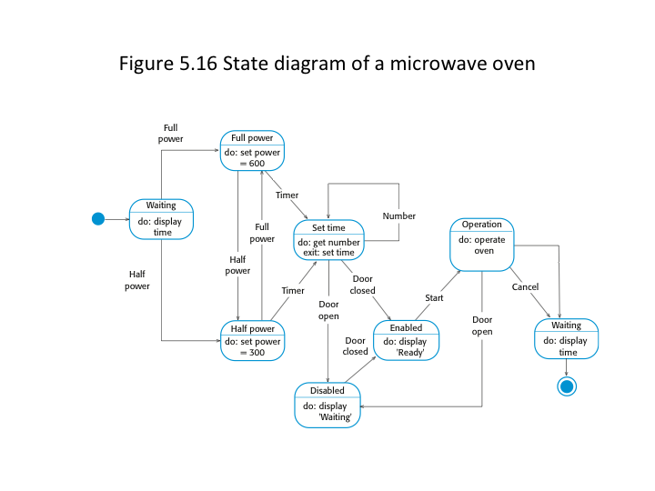

**State Table for the Microwave**

|  |  |  |  |  |  |  |  |  |  |  |
| --- | --- | --- | --- | --- | --- | --- | --- | --- | --- | --- |
| State \ Inputs | Command Full Power | Command Half Power | Command Timer | Command Number | Command Exit | Door open | Door closed | Command Start | Command timeout | Command Cancel |
| Waiting | Full power: Set power=600 | Half power: Set power=300 |  |  |  |  |  |  |  |  |
| Full power |  | Half power: Set power=300 | Set time: get number |  |  |  |  |  |  |  |
| Half power | Full power: Set power=600 |  | Set time: get number |  |  |  |  |  |  |  |
| Set time |  |  |  | Set time: get number | Set time: set time | Disabled: display ‘Waiting’ | Enabled: display ‘Ready’ |  |  |  |
| Enabled |  |  |  |  |  |  |  | Operation: operate oven |  |  |
| Disabled |  |  |  |  |  |  | Enabled: display ‘Ready’ |  |  |  |
| Operation |  |  |  |  |  | Disabled: display ‘Waiting’ |  |  | Waiting: display time | Waiting: display time |

**Test Cases**

|  |  |  |  |  |
| --- | --- | --- | --- | --- |
| Test Case ID | Current State | Command/Sensor | Action | Next State |
| T-001 | Waiting | Full power | Set power=600 | Full Power |
| T-002 | Waiting | Half Power | Set power=300 | Half Power |
| T-003 | Waiting | Timer | Nothing | Waiting |
| T-004 | Waiting | Number | Nothing | Waiting |
| T-005 | Waiting | Exit | Nothing | Waiting |
| T-006 | Waiting | Door open | Nothing | Waiting |
| T-007 | Waiting | Door closed | Nothing | Waiting |
| T-008 | Waiting | Start | Nothing | Waiting |
| T-009 | Waiting | Timeout | Nothing | Waiting |
| T-010 | Waiting | Cancel | Nothing | Waiting |
| T-011 | Full Power | Full power | Nothing | Full Power |
| T-012 | Full Power | Half Power | Nothing | Full Power |
| T-013 | Full Power | Timer | Set power=300 | Half Power |
| T-014 | Full Power | Number | Get Number | Set time |
| T-015 | Full Power | Exit | Nothing | Full Power |
| T-016 | Full Power | Door open | Nothing | Full Power |
| T-017 | Full Power | Door closed | Nothing | Full Power |
| T-018 | Full Power | Start | Nothing | Full Power |
| T-019 | Full Power | Timeout | Nothing | Full Power |
| T-020 | Full Power | Cancel | Nothing | Full Power |
| T-021 | Half Power | Full power | Set power=600 | Full Power |
| T-022 | Half Power | Half Power | Nothing | Half Power |
| T-023 | Half Power | Timer | Get Number | Set time |
| T-024 | Half Power | Number | Nothing | Half Power |
| T-025 | Half Power | Exit | Nothing | Half Power |
| T-026 | Half Power | Door open | Nothing | Half Power |
| T-027 | Half Power | Door closed | Nothing | Half Power |
| T-028 | Half Power | Start | Nothing | Half Power |
| T-029 | Half Power | Timeout | Nothing | Half Power |
| T-030 | Half Power | Cancel | Nothing | Half Power |
| T-031 | Set time | Full power | Nothing | Set time |
| T-032 | Set time | Half Power | Nothing | Set time |
| T-033 | Set time | Timer | Nothing | Set time |
| T-034 | Set time | Number | Get Number | Set time |
| T-035 | Set time | Exit | Set Time | Set time |
| T-036 | Set time | Door open | Display ‘Waiting’ | Disabled |
| T-037 | Set time | Door closed | Display ‘Ready’ | Enabled |
| T-038 | Set time | Start | Nothing | Set time |
| T-039 | Set time | Timeout | Nothing | Set time |
| T-040 | Set time | Cancel | Nothing | Set time |
| T-041 | Enabled | Full power | Nothing | Enabled |
| T-042 | Enabled | Half Power | Nothing | Enabled |
| T-043 | Enabled | Timer | Nothing | Enabled |
| T-044 | Enabled | Number | Nothing | Enabled |
| T-045 | Enabled | Exit | Nothing | Enabled |
| T-046 | Enabled | Door open | Nothing | Enabled |
| T-047 | Enabled | Door closed | Nothing | Enabled |
| T-048 | Enabled | Start | Operate oven | Operation |
| T-049 | Enabled | Timeout | Nothing | Enabled |
| T-050 | Enabled | Cancel | Nothing | Enabled |
| T-051 | Disabled | Full power | Nothing | Disabled |
| T-052 | Disabled | Half Power | Nothing | Disabled |
| T-053 | Disabled | Timer | Nothing | Disabled |
| T-054 | Disabled | Number | Nothing | Disabled |
| T-055 | Disabled | Exit | Nothing | Disabled |
| T-056 | Disabled | Door open | Nothing | Disabled |
| T-057 | Disabled | Door closed | Display ‘Ready’ | Enabled |
| T-058 | Disabled | Start | Nothing | Disabled |
| T-059 | Disabled | Timeout | Nothing | Disabled |
| T-060 | Disabled | Cancel | Nothing | Disabled |
| T-061 | Operation | Full power | Nothing | Operation |
| T-062 | Operation | Half Power | Nothing | Operation |
| T-063 | Operation | Timer | Nothing | Operation |
| T-064 | Operation | Number | Nothing | Operation |
| T-065 | Operation | Exit | Nothing | Operation |
| T-066 | Operation | Door open | Display ‘Waiting’ | Disabled |
| T-067 | Operation | Door closed | Nothing | Operation |
| T-068 | Operation | Start | Nothing | Operation |
| T-069 | Operation | Timeout | Display time | Waiting |
| T-070 | Operation | Cancel | Display time | Waiting |

**Lessons Learned**

When

**Honor Pledge**

We pledge on our honor that we have not given or received any unauthorized assistance on this assignment/examination. We further pledge that we have not copied any material from a book, article, the Internet or any other source except where I have expressly cited the source.